PRIYANKA CHAVAN

SOC ANALYST | CYBER SECURITY ENGINEER | INCIDENT RESPONSE SECURITY ANALYST




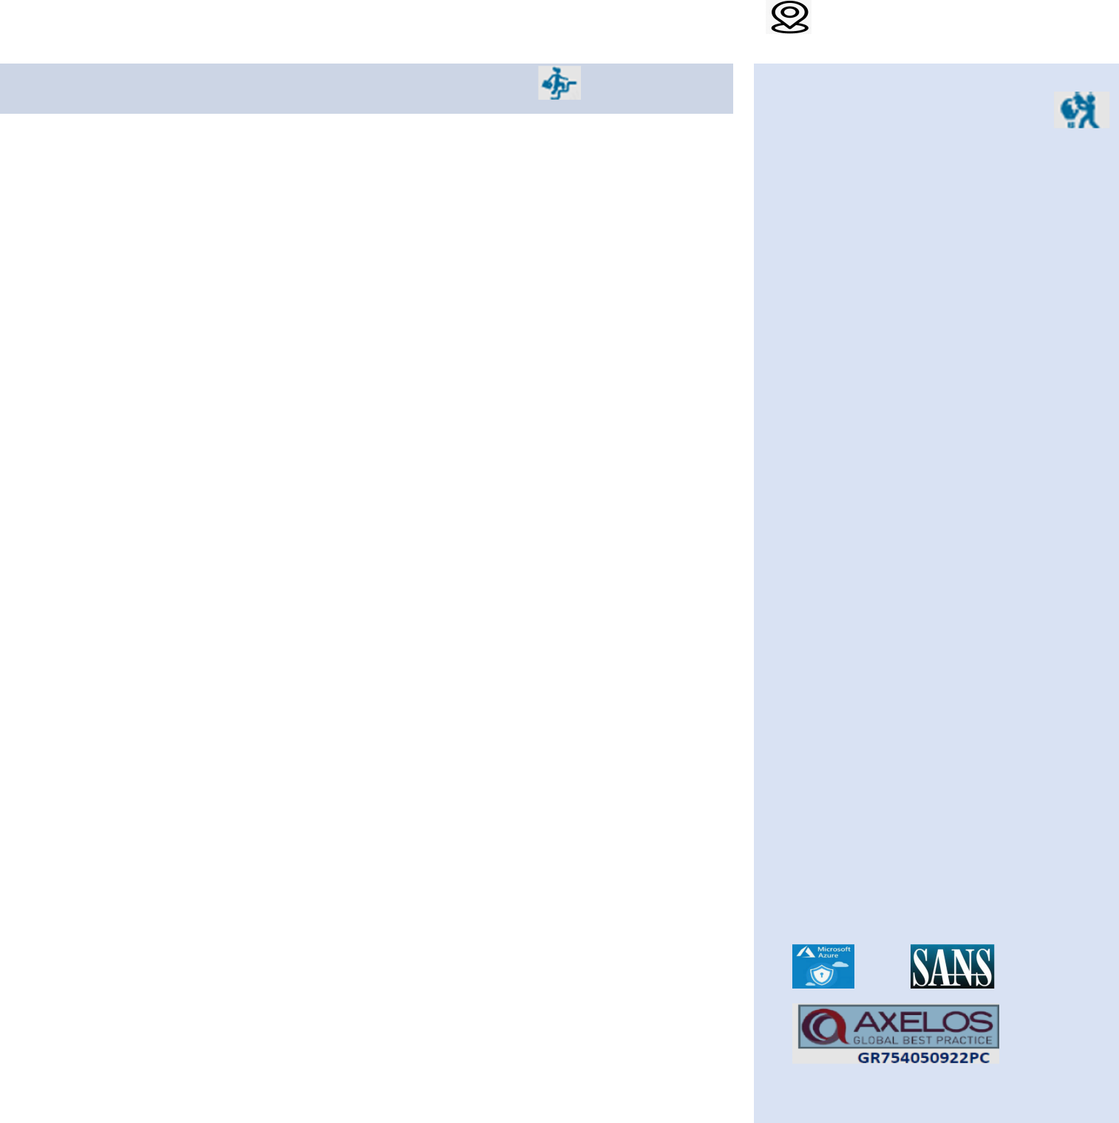

OBJECTIVE:

Cyber Security Engineer with 9+ years of Experience with bachelor’s degree in information technology & Engineering. Expertise in incident response and a strong understanding of security operations, seeking a challenging role in a dynamic organization where I can utilize my technical knowledge, incident handling experience, and analytical skills to effectively detect, respond to, and mitigate security incidents, ultimately enhancing the organization's overall security posture.

TECHNICAL SKILLS:

- SOC Tools: RSA net witness and Qradar, Splunk (SIEM tool), IBM and Recorded Future (threat intelligence), Nessus scanner, Service Now (CA service Desk Nexthink, Crowdstike and Endgame EDR solution IronPort and TrendMicro Email Security, TrendMicro and Kaspersky (Antivirus) and Link Shadow , XSOAR, Forcepoint DLP , Last line and Core light NDR solutions, Fortinet and Palo Alto Firewall.

- Applications: Qatar Government websites, Commerce and Industry application, Banking application (Marketdata, FX, Dbeagle,DbDeals Info, MS office based app, web application ,reporting stacks ETL )

- Programming Languages: Unix Shell Scripting, PL/SQL, JavaScript

ACADEMIC QUALIFICATION:

Bachelor of Engineering in Information Technology from Shivaji University, India in 2014.

Post Graduate Diploma from Center for Development Advanced Computing, India in 2015.

PROFESSIONAL SYNOPSIS:

- Experienced Cyber Security Engineer adept at designing and implementing robust security solutions. Skilled in risk assessment, vulnerability management, and deploying advanced security technologies. Collaborative team player with a proactive approach to addressing emerging cyber threats and ensuring compliance with industry standards.

- Experienced with Cyber Security Frameworks such as ISO27001, NIA, Qatar Cyber Security Framework 2022.

TRAINING AND CERTIFICATION: 

- ITIL Foundation & ITIL SO Certification.

- C-DAC Certification.

- Certified SOC Analyst (SIEM).

- Completed Microsoft Azure Security, Administrator (AZ-500, AZ-103) training

- Preparing for SANS GCIH

EMPLOYMENT HISTORY:

SOC Analyst (L3) | (April 2021 to till the date)
OISSG Consultancy, Client: Public Prosecution (PP), Qatar
Key Result Area: Public Prosecution organization security

- Lead and coordinate incident response efforts, including assigning tasks, providing guidance to L2 analysts, and ensuring timely and effective incident resolution. Develop and implement incident response plans and procedures.

- Security Tools Management: Manage and fine-tune security tools such as Qradar SIEM, Forcepoint DLP, Link shadow, IronPort, TrendMicro DDEI, XSOAR, Nessus-Tenable, crowdstrike and other security technologies. Ensure their proper configuration, optimization, and integration with other security systems.

- Develop and maintain incident response plans and playbooks to guide the organization's response to security incidents and data breaches. Lead incident response efforts to contain, investigate, and remediate security incidents in a timely and effective manner.

- Onboarding new security solution and applied best practices as per Cyber security framework. Participated in implementation of cyber tabletop exercise to identify different risk scenarios and prepare them for cyber threat discovery & modelling management.

- Ensure compliance with relevant cybersecurity laws, regulations, and industry standards applicable to the organization's operations. Maintain awareness of regulatory changes and evolving compliance requirements and implement controls to address compliance gaps.
- Participate in implementation of Q2022 cyber security framework, ISO27001 and NIA project in Public Prosecution.

SOC Analyst L2 | (Oct 2019 to Mar 2021)
OISSG Consultancy, Client: Ministry of Commerce & Industry (MOCI), Qatar
Key Result Area: MOCI organization security

- Security monitoring experience with one or more SIEM technologies – RSA Net witness, azure sentinel and intrusion detection technologies.

- Monitor security events from the various SOC entry channels (SIEM tool, Email and Phone), based on the security event severity to perform further investigation and resolution.

- Basic knowledge of client-server applications, multi-tier web applications, relational databases, firewalls, VPNs, and enterprise Anti-Virus products.

- Strong understanding of security incident management, malware management and vulnerability management processes.

- Part of Vulnerability management, perform application and OS level scan using Nessus, IBM scanner and report to respective team.

- Define and implement use cases based on standard methodologies in RSA net witness SIEM tool.

- Works as part of a team to ensure that corporate data and technology platform components are safeguarded from known threats & modelling management

- Staying up to date with emerging security threats including applicable regulatory security requirements.

- Working with Microsoft team to set up azure sentinel.

Sr. SYSTEM ENGINEER | (Aug 2017 to May 2019)
INFOSYS, Client: UBS, INDIA.
Key Result Area: UBS Bank Application (Risk Analytics)

- Troubleshooting various Database and Application-Level issues. Performance monitoring on grid server and fix on defects. Work with security teams to perform tests and uncover network and application vulnerabilities.

- Analyzing of High CPU loads, Tablespace Usage, Critical Table Growths, Invalids and Alerts logs of Unix Server and database on daily basis. Monitoring the CPU usage, IO statistics, and CPU time to identify any OS level Performance issues using Splunk (SOC, SIEM tool). Taking care of all other daily routine tasks like creating users, roles, tablespace, addressing alerts triggered from monitoring tools etc.

- Reporting data verification after necessary analysis on different revenue streams. Planning and implementation of ERP, up-gradation, enhancements, release, or any changes in the existing functionality of the systems as per business requirements. Perform and test routine system backups and restores.

- Responsible to monitor the Application infrastructure in 24*7 and respond to all kind of cyber-attacks. Worked on SIEM tool for monitoring and analysis of cyber-attack Splunk. Also responsible for real world cyber-attacks and investigating on attacks with the help of network packet and device log.

SYSTEM ANALYST | (Jan 2015 to Aug 2017)
Deutsche Bank, INDIA
Key Result Area: Corporate Finance

- Successfully completed the transition which was expected to take place in three phase, first of all Knowledge acquisition from Client and Vendors then Shadow Support and followed by Steady Support Stage.

- Ability to write/prepare various scripts in Linux/Unix, PL/SQL.

- Geneos Monitoring Tool - Proactive monitoring has done for Unix server, DAP, Mesh, error logs, Jobs, Shell scripts, database scripts. Job configuration, scheduling and monitoring using App View/ControlM

- Handling user query, server related production issues captured with the help of Virtual ticket/Incident management system as per ITIL process.

- Proactive Monitoring of the various UNIX application servers, Handling live issues with the Broadband orders and providing workarounds/solutions.

DECLARATION:

I hereby declare that the above written particulars are true and correct to the best of my knowledge and belief.

Date:

Place: Abu Dhabi,UAE Priyanka Chavan

